Dear Family and Friends, December 15, 2011

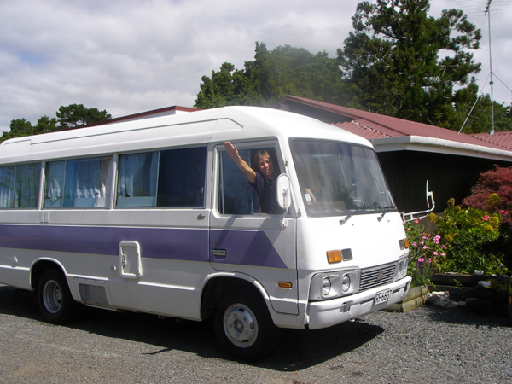
The Cruising Colemans have finally landed. As most will recall, after living aboard for nearly 20 years, we sold our beloved Southern Cross when we arrived in New Zealand in 2008. In September 2009, we bought a 1980 bus that had been converted to a campervan and with the help of our Kiwi “Mom and Pop,” Brian and Heather, we fixed it up into a comfortable land cruiser we named Sweet Pea (left.)
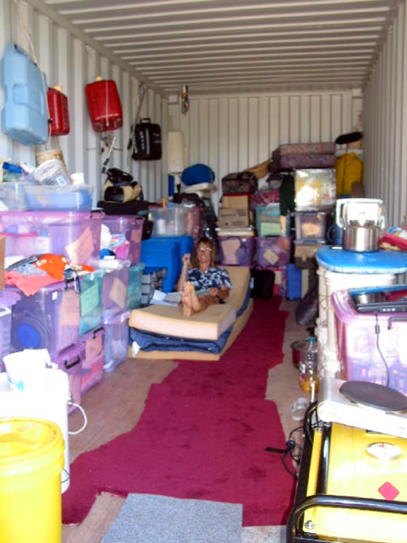
We also bought an almost new 20 foot forest green shipping container that Heather named Green Peace (GP) and, after Lorraine varnished the pristine apitong floors, we stashed all our belongings and treasures collected after years of cruising into it.
We even slept in GP (photo right) when our camper was having a new radiator installed. The good times we had exploring New Zealand, sojourning with all our extended family and friends, like Brian and Heather, Don and Jacquie, Captain Murray, Johnny, Kerry and Jan, et al are legion and will eventually make it into our book.
US citizens are only allowed a 6 month visitor’s permit in NZ but we became “overstayers” in March 2010 when I got a life threatening infection after cataract surgery and went blind in my left eye, The emergency surgery (vitrectomy) and months of intense antibiotics, Prednisone and other meds worked - my sight mostly returned. Since I was stuck in NZ and the medical costs are less than half the US, I had hernias re-repaired on both sides and a cartilage-eating organism cut out of my right ear. (At the end of the year I also had a skin cancer cut from my forehead.) The Chinese call 2010 “The Year of the Tiger,” but I named it “The Year of the Knife!”
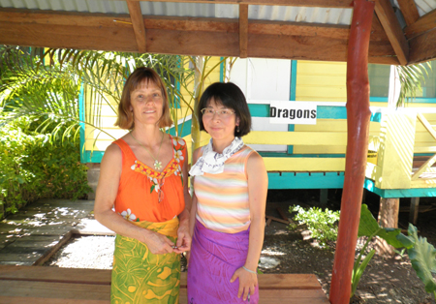
We had hoped to find a small house in New Zealand with some land to set Green Peace (GP) on and a shed to park Sweet Pea in when we left, but to no avail. May 2010, we moved Sweet Pea to our friend’s (Kerry and Jan’s) barn and left our belongings and GP at Brian and Heather’s, knowing we would be unable to return till December 2011. Our new Japanese friend Chiaki (photo left) joined us when we flew to Samoa to search for a “nest” for the now-homeless, boatless sailors.

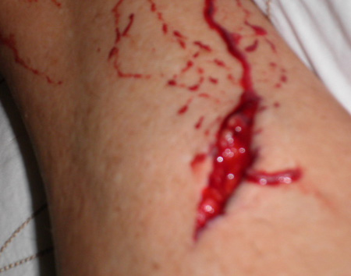
Samoa would have worked for us fine were it not for the myriad feral dogs everywhere. Jogging, bicycle riding, mo-pedding, even strolling in residential neighborhoods are often hazardous endeavors. All the locals take taxis. Lorraine was savagely bitten and although the doctor did a fine job stitching her up, the wound still got infected. The Tourism officials and even the Prime Minister did their utmost to make the rest of our 6-week stay there as nice as possible and we are forever indebted to them, but mermaid Lorraine had to eschew all swimming and snorkeling for the following 3 months it took to heal.
Chiaki flew off to Australia and we flew to American Samoa for a few days but even though it is one of the most stunningly beautiful islands we ever visited, the atmosphere of the place turned us off. One American Samoan gal told Lorraine “You should apply for food stamps. Everyone gets them here.” We have never asked our government for anything – not our style. In early July 2010, we hopped on another plane and flew to Honolulu and then on to San Diego where we packed up our old van, Baby Blue; and drove almost non-stop north to check on our 2 four-plexes in Clarkston Washington that we had not seen in nearly 20 years. They needed more than a little attention.
In our last update, (hard to believe a whole year has passed), I wrote “We worked all day every day 12-14 hours a day till November 9th installing new flooring, carpets, painting all insides and outside, re-graveling the parking lot, pruning trees, putting in all new fences and on and on. Some before and after pictures are on this link, http://www.alohacouple.com/Back%20in%20San%20Diego%202010.htm . We met many fine hardworking folks who helped us or we would be still up there freezing. We also found a wonderful new property manager, Melba, to care for our apartments and left one week before the first snowfall.”
We visited a few friends and Mom and Brother Joe on the way south and decided to fly to Molokai (30 miles east of Oahu in Hawaii) to find a home or build one on the small piece of red island dirt we had purchased in 2004. We spent New Years night with our friends Jim and Cyndy in Camarillo and stayed for a week to help them out. Jim died of ALS on June 29th and we are SO glad we spent the time with them that we did. The rest of January this year was spent moving our stuff that had been in our best friend Joe’s house in San Diego for a decade and a half and combining it with our things in storage at Global Moving.
It would have been ideal to go through everything and have garage sales (the stuff in Global had been there almost 20 years), but no space or time, so we opted to have it all shipped to Molokai after we found a place there. We also removed everything but the jack from our van, Baby Blue, in San Diego and arranged to have her shipped to Molokai. More traveling - this time to Hawaii where we stayed at our pals (the Carrols) in Honolulu for a week at the end of January and reconnected with old friends. We flew to our new island home, Molokai, on February first and rented a cool condo on the south shore. Baby Blue arrived a week after we did so we had wheels.
Lorraine and I had been living out of suitcases since we left Southern Cross the first time back at the end of May 2009, well over a year and a half. Lorraine said “I just want to have a few drawers,” so we spent February searching for her long-awaited “nest.” House prices have come down across the country but not construction costs, especially including shipping all materials by barge to Molokai, so we gave up any idea of building a home here. Our wonderful Realtor friend, Diane, showed us every single family home for sale on this island in one day, not a huge choice. (There are only 7500 people on Molokai.)
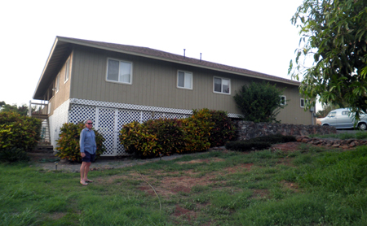
Very sadly, near the end of January, we received an email from Kerry and Jan in New Zealand that their cattle ranch had been flooded by Cyclone Wilma and Sweet Pea had been fully submerged and ruined. They stood in the loft in their beautiful barn that they had turned into a fine home, and watched in horror as the flood waters rose to their ankles and their cows swam frantically by. It seems we are perpetually ‘regrouping” and this depressing incident (along with an insurance settlement for about 2/3 of the amount we had in Sweet Pea,) helped us make a decision on which home to buy.
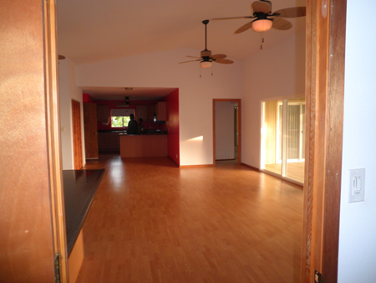
We found a wonderful 1700 square foot home (right), built in 2005 in an older sub-division called “The Heights” – less than 2 miles from Kaunakakai town and 500 feet above the tsunami and flood zones. It has a nice south facing view to Lanai from a 20 by 40 foot deck and 2 master bedrooms and baths on a half acre. It is far nicer than anything we had imagined but took almost all our savings/retirement to buy it. We moved in with suitcases and nothing else on March 4th.
“Nothing” means just that. There was a microwave and a dishwasher (only because they were built in) but no stove or refrigerator, and we had no dishes to eat off of (much less wash,) no silverware, no bowl to heat things in the micro, no soap, towels, tools and on and on. Diane lent us 2 wood patio chairs; a couple plates, knives and forks, a coffee maker and 2 wine glasses and we were set! Kind of. We moved the cushions from Baby Blue into one of the bedrooms, and used some lava lavas (sarongs or pareaus) for sheets. Dan, our neighbor next door lent us a blanket after we froze the first night.

Five days later, Lorraine flew to Honolulu to house sit for friends and buy a fridge, stove, some used furniture, food, and other household things. She shipped over piles of stuff by barge while I moved it into the house and set things up; cleaned up the overgrown yard with help from our new friend Milton, installed gas lines for the new stove, and on and on. We both worked our tails off as we always do.
The day after she returned, March 28th, our furniture and things arrived from San Diego and we spent the next few months unpacking, setting up Lorraine’s nest, repairing furniture that had broken in transit, trying to get the yard under control, and planting some vegetables in the rocky ground – sailors turned farmers. I also arranged to have Green Peace shipped from New Zealand (a very time and money consuming endeavor) to Molokai.
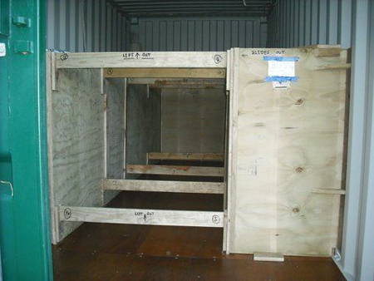
We paid Mum and Pop in NZ to purchase lumber and plywood and to build boxes to secure our belongings for shipping. Brian crafted an ingenious creation (see photo right – note pristine varnished floors) that held everything securely but could be easily opened for inspection should US Customs decide to take a look when it arrive in Honolulu. Everything was marked “Lift out” or “Remove bolt and slide” with a directional arrow. Thanks Mum and Pop. A trucker picked up GP and delivered it to Auckland where she was loaded aboard the Australia New Zealand cargo ship, BINBURRA. She departed July 11th Honolulu bound.
We tracked BINBURRA and Green Peace across the Pacific and they arrived safe and sound in Honolulu harbor on July 22nd. Lorraine had flown over a few days earlier to buy gutter and irrigation pipe and more supplies for our home here on Molokai. Our container was only about 1/3rd full so we arranged to have Green Peace moved to a trucker’s yard when she was unloaded off the ship where Lorraine could open it and put our things in instead of shipping by barge (the only way to get things to Molokai.)
The following Thursday, our world blew up again -- US Customs/Border Protection (CBP) seized our container and we were forced to have it moved to their Centralized Examination Station (CES) in Honolulu run by Island Movers where we would have to pay storage at $75 a day till CBP released it. Our summer, fall and bank account were ruined. Lorraine dropped off the key at our Custom’s Broker’s office; paid to have her purchases shipped by barge to Molokai; and flew home completely distraught. We were told by a CBP agent the following day (Friday) that they were looking for “guns or drugs” and “if there were any issues,” she would never speak to us again.
Lorraine and I knew there were no guns or drugs, but we still fretted and stewed all weekend, wondering how much this delay would cost and how long it would take. We had compiled an inventory from memory but we had not seen most of our things since September 2009, and none of them since May 2010! We knew there must be omissions. What if we had left something off and they accused us of trying to smuggle it in? What if Brian and Heather had stashed a few bottles of their wine (they are 2 of the best winemakers in NZ) as a surprise gift for us in GP? Would they arrest me for smuggling booze? Monday things worsened. Green Peace was locked up and it would be 2 weeks before they finally released her. We hardly slept during that time.
Tuesday afternoon, August 2nd, the gal at the Examination Station (CES) told us that, without our knowledge or permission, EVERYTHING had been taken out of Green Peace for no reason whatsoever, at a cost of $750.00, and then searched and put into storage. And that every bit of wood had been taken out of GP and cut into firewood size pieces! She said that Customs had ordered Island Movers to dismantle the plywood boxes that our Mum and Pop had so carefully built in NZ; remove ALL the timber from Green Peace (including teak wood we’d carried aboard our boat since 1995;) cut it all up into unusable small pieces; buy plastic “bins”; fill the “non-compliant” wood into them, and prepare them to be air freighted to New Zealand, all at our cost.
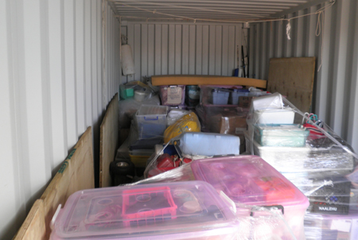
It’s like TSA tearing apart your luggage at the airport and then handing you a huge bill and refusing to give back your luggage till you pay the bill. Lunacy! I had originally included all the details of the horror story but decided most people would not want to read about our travails that are still ongoing to this day.
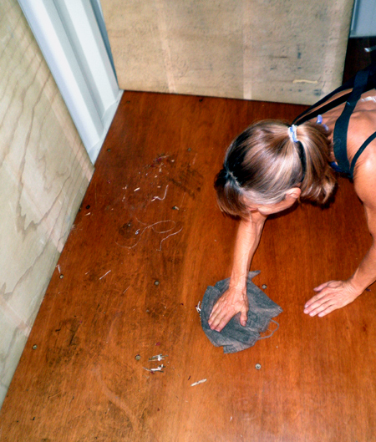
On August 12th, 18 days after she arrived from New Zealand, Green Peace finally made it to our home on Molokai. When we got her to the house and opened her we were shocked to find all was filthy in and out, completely disheveled, the varnished floor was severely gouged; 14 of our plastic storage boxes broken; and our teak wood from Southern Cross and other wood was missing! (See the 2 photos on the previous page. The bottom shows how Island Movers “repacked” GP compared to the one at the top as GP looked when she arrived in Honolulu.)
They dropped screws all over the varnished floor and then drove their forklift over them. And they ripped out wood attached to our beautiful apitong floor with a hammer, gouging the hell out of it instead of simply unscrewing it. It took days, to clean things up (Lorraine’s rag in the photo at right was white when she started) – not the happy reunion we had planned with our treasures from Southern Cross.
We have been in and dealt with countless Customs and other government offices in many countries and were never treated as terribly as we have been just trying to move back to the US. The whole nightmare has cost us nearly $3,000! And that does not include costs to repair GP and replace the broken boxes. Fortunately, our Senator from Hawaii (Senator Akaka) has launched a “formal inquiry” into the matter, but no results yet.

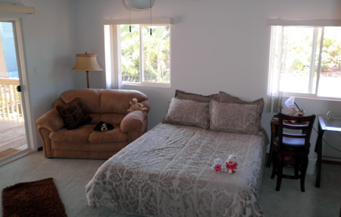
Lorraine and I are moving on (figuratively – we have the anchor well set right now) and we’ll write about our new home, friends, garden, the wild cat we adopted, and life on Molokai next update. Remember we have a beautiful spare master bedroom (left) and bath for all who wish to visit and the weather here is almost always perfect. Thanks to all our friends and extended family. We wish you all good health and a better New Year.

Love and aloha from the ‘Friendly Isle,”
Robby and Lorraine

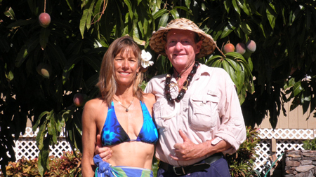

P.S. 12/16/2011 Just when we thought our world might mellow out—KABLOOOEY. Found out last night, when I was ready to send this email, that my youngest and only surviving brother Joe, was in a motorcycle wreck yesterday with a broken back and multiple injuries. Anybody, anywhere, anytime. We have one go-round here, make it your best!

